MOTION NO. 001-2024 – MOTION TO APPROVE THE EXISTING DISCLOSING WRONGFUL CONDUCT (WHISTLEBLOWER) POLICY

It was MOVED by Ms. Granger seconded by Ms. Pulliam, and unanimously adopted by voice vote by members present by video or in person, to approve the existing “Disclosing Wrongful Conduct (Whistleblower) Policy” MOTION CARRIED.

* * * * * * * * *

STATE OF NEW YORK )
GTCMHIC ) ss:
COUNTY OF TOMPKINS )

I hereby certify that the foregoing is a true and correct transcript of a motion adopted by the Greater Tompkins County Municipal Health Insurance Consortium Operations Committee on the date of June 6, 2024.
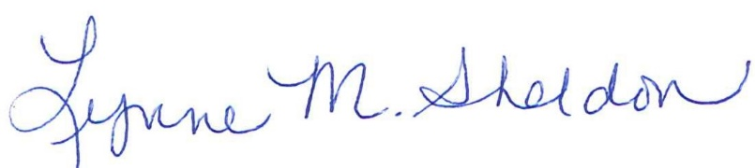

______________________________________
Lynne Sheldon, Clerk of the GTCMHIC Board

