RESOLUTION NO. 039–2022 - AUTHORIZE PURCHASE OF STOP LOSS INSURANCE FOR 2023

WHEREAS, the Consortium must purchase stop loss insurance, as required by Section 4707 of New York State Insurance Law, now therefore be it

RESOLVED, on recommendation of the Audit and Finance Committee, That the Board of Directors authorizes the purchase of the Stop Loss insurance policy with a deductible of $1 million for the policy period January 1, 2023 to December 31, 2023 with Highmark to include claims incurred from January 1, 2023 thru December 31, 2023 and paid during the period of January 1, 2023 thru March 31, 2024.

RESOLVED, further, That the Plan Consultant is directed to provide the Executive Director with a copy of said policy.

********

STATE OF NEW YORK )
GTCMHIC ) ss:
COUNTY OF TOMPKINS )

I hereby certify that the foregoing is a true and correct transcript of a resolution adopted by the Greater Tompkins County Municipal Health Insurance Consortium Executive Committee on behalf of the Board of Directors on December 7, 2022.
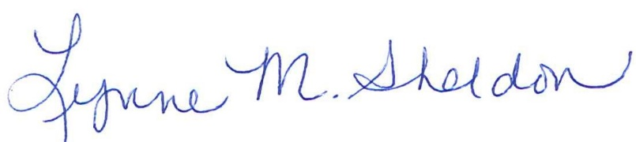

______________________________________
Lynne Sheldon, Clerk of the GTCMHIC Board

