RESOLUTION NO. 034-2022 – APPROVAL OF NEW CONTRACT FOR PLAN CONSULTANT – LOCEY & CAHILL, LLC – JANUARY 1, 2023 – DECEMBER 31, 2026

MOVED by Mr. Snow, seconded by Ms. Holmes. The resolution was unanimously adopted by voice vote of members present, visibly seen members via remote Satellite locations, and locations due to extraordinary circumstances.

WHEREAS, the Consortium requires ongoing Plan consulting services to continue its operations, and
WHEREAS, the Executive Committee has discussed the need and scope of Benefit Plan Consultant Services and recommends that the Consortium continue to retain Locey & Cahill, LLC for those services, and
WHEREAS, the Audit and Finance Committee has reviewed and discussed the terms of the Consortium’s contract with Locey and Cahill, LLC, and
WHEREAS, Locey & Cahill, LLC presented an agreement that shall become effective of January 1, 2023 and remain in effect through December 31, 2023. Thereafter, the Consortium has the option to extend this contract in one-year increments through December 31, 2026.

RESOLVED, on recommendation of the Audit and Finance Committee, That the Board of Directors hereby approves its contract with Locey & Cahill, LLC of the agreement contract for the period January 1, 2023 through December 31, 2023.

* * * * * * * * * *

STATE OF NEW YORK )
GTCMHIC ) ss:
COUNTY OF TOMPKINS )

I hereby certify that the foregoing is a true and correct transcript of a resolution adopted by the Greater Tompkins County Municipal Health Insurance Consortium Executive Committee on behalf of the Board of Directors on December 7, 2022.
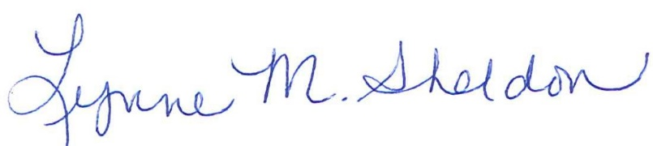

______________________________________
Lynne Sheldon, Clerk of the GTCMHIC Board

