RESOLUTION NO. 032 - 2022 – AMENDMENT TO RESOLUTION NO. 011-2020 “Authorization by the Board of Directors to Remove Benefit Plans from the Consortium’s menu OF Benefit Plan Offerings” BY RESTRICTING PLAN ENROLLMENT

MOVED by Ms. Holmes, seconded by Mr. Hall. The resolution was unanimously adopted by voice vote of members present, visibly seen members via remote Satellite locations, and locations due to extraordinary circumstances.

WHEREAS, to achieve administrative efficiencies the Consortium removed from the Consortium’s Menu of Benefit Plan Offerings effective January 1, 2021 the following benefit plans:
- Indemnity Plan MM3
Plan Description:
MM3 – Basic Benefits with “Major Medical” $100/$200 Deductible & $750/$2,250 Out-of-Pocket Maximum

- Medicare Supplement Plans MS1. MS2. MS5, and MS6
Plan Descriptions:
MS1 - Medicare Supplement Plans with No Prescription Drug Coverage
MS2 - Medicare Supplement Plans with $5/$15/$30 Rx Copay Plan
MS5 - Medicare Supplement Plans with 20%/20%/40% Rx Copay Plan
MS6 - Medicare Supplement Plans with 20%/30%/50% Rx Copay Plan

, and
WHEREAS, to achieve further administrative efficiencies the Consortium wishes to continue consolidation and streamlining its menu of benefit plan offerings, and

WHEREAS, although included in the menu of benefit plan offerings, there are medical and prescription drug plans that are not being utilized by Consortium Participants and have no one enrolled or less than five Participants, and

WHEREAS, the removal of these plans from the Consortium’s menu of benefit plans has been recommended by the Consortium’s Consultants, now therefore be it

RESOLVED, on recommendation of the Operations Committee and the Joint Committee on Plan Structure and Design, That the Executive Committee, on behalf of the Board of Directors, hereby Amends Resolution No. 011-2020 “Authorization by the Board of Directors to Remove Benefit Plans from the Consortium’s Menu of Benefit Plan Offerings” to include the following benefit plans be removed from the Consortium’s Menu of Benefit Plan Offerings, and any new Participants will be restricted from enrolling in the following plans due to low enrollment.

MM3- Classic Blue MM RX (No ProAct Prescription coverage) $50/$150 Deductible & $400/$1,200 Out-of-Pocket Maximum
End Date: December 31, 2022

PPO3- PPO $20/35 with $2,000/$6,000 Out-of-Pocket Maximum and $750/$2,250 Out of Network Deductible
End Date: December 31, 2022

MM6- Comprehensive Plan with $500/$1,500 Deductible & $2,500/$7,500 Out-of-Pocket Maximum
End Date: December 31, 2023
* * * * * * * * * *

STATE OF NEW YORK )
GTCMHIC ) ss:
COUNTY OF TOMPKINS )

I hereby certify that the foregoing is a true and correct transcript of a resolution adopted by the Greater Tompkins County Municipal Health Insurance Consortium Executive Committee on December 7, 2022.

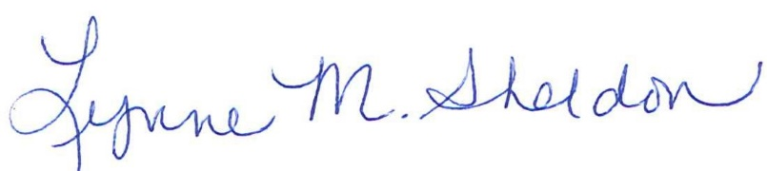

______________________________________
Lynne Sheldon, Clerk of the GTCMHIC Board

