RESOLUTION NO. 020 - 2022 - RESOLUTION OF APPRECIATION OF RICHARD C. SNYDER’S

DEDICATED YEARS OF SERVICE TO THE CONSORTIUM

WHEREAS, when Tompkins County hired Richard C. Snyder (Rick Snyder) in 2013 the Greater Tompkins County Municipal Health Insurance Consortium was fortunate enough to have already contracted with Tompkins County for Finance and Accounting Services.

WHEREAS, Rick, in addition to his full-time Director of Finance position with Tompkins County, was “volunteered” to be the Consortium’s Treasurer and ended up “volunteering” with the Consortium as not just the Treasurer but also ran accounting services for the Consortium for nine years, and

WHEREAS, in addition to his full-time job at Tompkins County, Rick has been known to attend many evening meetings and work odd hours in support of the Consortium,

WHEREAS, the Consortium has been able to secure many services and expert support by taking advantage of Rick’s Tompkins County relationships, and

WHEREAS, for many years Rick has learned the challenges associated with quarterly and annual financial reports and has dutifully responded to the myriad of questions that follows any interaction with the NYS Department of Financial Services, and

WHEREAS, Rick has an amazing archive of emails and memos regarding the Consortium’s business interactions that he is able to pull-up at a moments notice, and

WHEREAS, Rick’s role has changed over the years as the needs of a growing organization transformed, but his commitment to accurate reporting and accounting practices have always remained steadfast, and

WHEREAS, Rick is now at a stage in life where he can celebrate retirement both from Tompkins County as well as the Consortium, and

WHEREAS , Rick is wished much happiness as he steps down and finds time to explore other experiences that bring him joy with his friends and family, now therefore be it

RESOLVED, That the Board of Directors, staff, consultants, advisors, and associates, acknowledge the retirement of Rick Snyder and are appreciative for his many devoted and exemplary years of service,

RESOLVED, further, That on this 22nd day of September 2022, the Board of Directors expresses its sincere gratitude to Richard C. Snyder for his distinguished and dedicated service to the Greater Tompkins County Municipal Health Insurance Consortium.
* * * * * * * * *

STATE OF NEW YORK )
GTCMHIC ) ss:
COUNTY OF TOMPKINS )

I hereby certify that the foregoing is a true and correct transcript of a resolution adopted by the Greater Tompkins County Municipal Health Insurance Consortium Board of Directors on September 22, 2022.
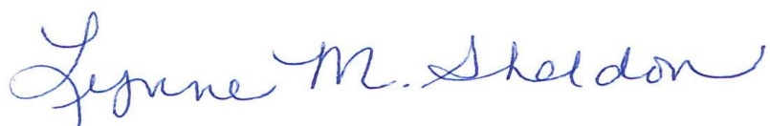

_______________________________________
Lynne M. Sheldon, Clerk of the GTCMHIC Board

