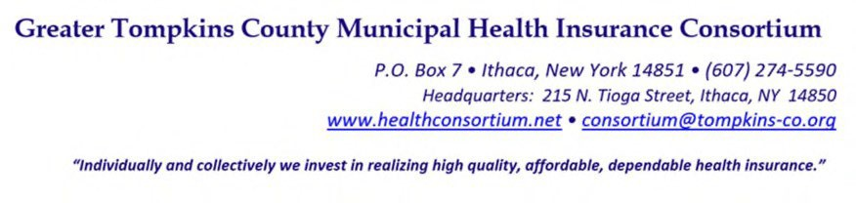
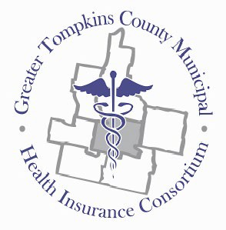

RESOLUTION NO. 017 - 2022 – ADOPTION OF AMENDMENT TO INVESTMENT MANAGEMENT POLICY

MOVED by Mr. Thayer, seconded by Mr. Snow, and unanimously adopted by voice vote by members present.

WHEREAS, the Consortium’s Investment Management Policy currently restricts the Consortium from investing in additional investment vehicles that are authorized under General Municipal Law (GML), and

WHEREAS, upon discussion by the Investment Management Subcommittee, there is interest in allowing the Consortium’s Investment Manager to have the ability to invest and capitalize on other
investments that are permitted under GML and structure a portfolio based on the Consortium’s cash
flow needs, utilizing instruments that would produce the best return, now therefore be it

RESOLVED, on recommendation of the Investment Management, Audit and Finance, and
Executive Committees, That the Board of Directors hereby approves the Consortium’s amended
Investment Management Policy.

* * * * * * * *

STATE OF NEW YORK )
GTCMHIC ) ss:
COUNTY OF TOMPKINS )

I hereby certify that the foregoing is a true and correct transcript of a resolution adopted by the Greater Tompkins County Municipal Health Insurance Consortium Executive Committee on behalf of the Board of Directors on August 3, 2022.

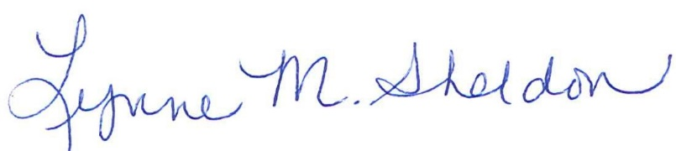

______________________________________
Lynne Sheldon, Clerk of the GTCMHIC Board

