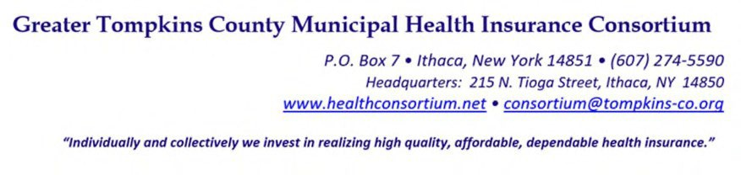

RESOLUTION NO. 016 - 2022 – AMENDMENT TO RESOLUTION N0. 014-2021 - CREATION OF 2022 COMMITTEE STRUCTURE AND APPOINTMENTS OF MEMBERS – APPOINTMENT OF KATE DEVOE TO AUDIT AND FINANCE COMMITTEE

WHEREAS, a vacancy on the Audit and Finance Committee exists because of the resignation of member Tim Arnold, and

WHEREAS, it is deemed to be in the best interest of Committee to continue to have a member who will represent the interests of labor on the Committee, now therefore be it

RESOLVED, on recommendation of the Audit and Finance Committee, That the Executive Committee, on behalf of the Board of Directors, appoints Kate DeVoe to the Audit and Finance Committee effective immediately with a term expiring December 31, 2023.

* * * * * * * *

STATE OF NEW YORK )
GTCMHIC ) ss:
COUNTY OF TOMPKINS )

I hereby certify that the foregoing is a true and correct transcript of a resolution adopted by the Greater Tompkins County Municipal Health Insurance Consortium Executive Committee on behalf of the Board of Directors on August 3, 2022.

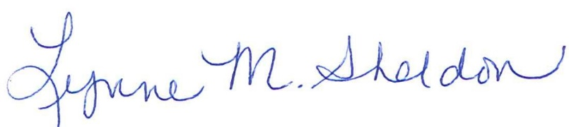

______________________________________
Lynne Sheldon, Clerk of the GTCMHIC Board

