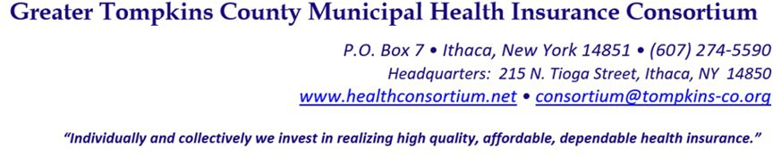

RESOLUTION NO. 014– 2022 – ADOPTION OF AMENDED APPLICATION PROCESS
(AMENDS RESOLUTION NOS. 6 OF 2019, 2 OF 2015, 7 OF

2018, 26 of 2014, AND 5 OF 2012 – APPLICATION MATERIALS MUNICPALITIES MUST PRESENT FOR APPLICATION TO JOIN THE CONSORTIUM

WHEREAS, the Greater Tompkins County Municipal Health Insurance Consortium (“Consortium”) Board of Directors initially adopted Resolution No. 005 of 2012 to provide guidance to eligible employers to apply for membership in the Consortium, and

WHEREAS, during the Consortium’s growth there have been numerous amendments to the original resolution and application process, and

WHEREAS, it is the recommendation of Consortium staff to replace specific components of the prior resolutions, such as deadlines and information requested of applicants to requirements that are better aligned with current practices and the Consortium’s Municipal Cooperative Agreement, now therefore be it

RESOLVED, on recommendation of the Operations and Audit and Finance Committees, That the Executive Committee on behalf of the Board of Directors, amends the Policy for Municipal Corporations seeking membership in the Consortium and Resolution Nos. 6 of 2019, 7 of 2018, 2 of 2015, 26 of 2014, and 5 of 2012 - Application Materials Municipalities Must Present for Application to Join the Consortium,

RESOLVED, further, that the application process, shall be reviewed annually if necessary by the appropriate committee of the Board of Directors.

Policy for Municipal Corporations seeking Membership in the Consortium

Annually a deadline will be posted as part of the application process when each of these documents need to be submitted by prospective new members.

- Submit application for membership with the Municipal Corporation’s required financial and operational documents, as follows:

  - for Municipal Corporations with taxing authority (county, city, town, or village), two years of State Comptroller AUD reports; or

  - for Municipal Corporations without taxing authority:

    - five years of audited financial statements;
    - internal governance documents and/or rules such as bylaws, resolutions, and/or statutes creating the Municipal Corporation; and
    - financial documents confirming funding sources, funding mechanisms, account balances, assets, investments, contractual obligations, and any debts, contingent liabilities, and/or lawsuits.

- Submit the Municipal Corporation’s most recent monthly premium billing statements from all health insurance carriers providing benefits to all active employees and retirees.

Said premium billing statements should include the name of the Municipal Corporation and the month for the which the billing is related. In addition, said premium bills must include the number of contracts (employee, employee + spouse, employee + child (children), and family) and the monthly premium rate for each plan of benefit.

- For Municipal Corporations who are currently experience-rated or who operate a self- insured employer-sponsored health insurance plan, they must submit a minimum of three
(3) years of monthly paid claims (medical and pharmacy separately) data and monthly covered lives counts.

- Upon notification that the GTCMHIC Board of Directors has approved the Municipal Corporation’s application to become a Participant in the GTCMHIC the prospective member must submit both a signed Municipal Cooperative Agreement (MCA) of the GTCMHIC and a resolution authorizing the Municipal Corporation’s Chief Officer to sign the Municipal Cooperative Agreement (MCA) of the GTCMHIC.

- When appropriate submit a Broker Termination Letter to current insurance carrier.

- Confirm by November 15th the names of all employees, retirees, and dependents to be covered in the Consortium’s health insurance plans.

- Notify the GTCMHIC of the name and contact information for the person within your organization for benefit administration; and who will attend a new member orientation.

- Comply with the Consortium’s Online Enrollment Policy.

- Municipal Corporations without taxing authority, provide the Consortium with a secure financial instrument equal to the value of 25% of the estimated annual premium as determined by the Consortium as protection against expulsion or cancellation due to a default in premium payment. Said financial instrument may include the following:

  - A Secured Bank Account;
  - Letter of Credit; or
  - Surety Bond

Please note, municipal corporations with taxing authority (county, city, town, or villages) will be exempt from this provision.

- Submit payment by December 31st to the Consortium for first month premiums, pay as invoiced in November of application year.

- As soon as practicable upon acceptance, provide written notification to the Consortium of the municipality’s appointment of Director and Alternate to the Consortium.

- As soon as practicable upon acceptance, provide written notification to the Consortium of the municipality’s appointment of a representative to the Joint Committee on Plan

Structure and Design.

- Take the necessary steps to comply with the GTCMHIC’s dependent verification process.

- All Municipal Corporations applying for Membership in the GTCMHIC are hereby advised that missing any of these steps by the due date indicated will result in the Municipal Corporation not being accepted into the Consortium for the upcoming year.

* * * * * * * *

STATE OF NEW YORK )
GTCMHIC ) ss:
COUNTY OF TOMPKINS )

I hereby certify that the foregoing is a true and correct transcript of a resolution adopted by the Greater Tompkins County Municipal Health Insurance Consortium Executive Committee on behalf of the Board of Directors on August 3, 2022.

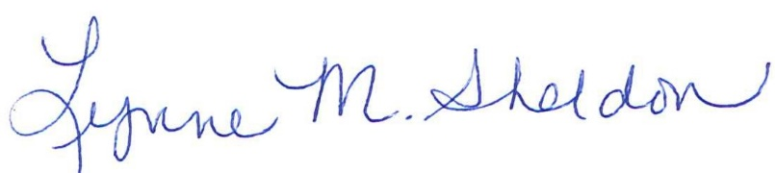

______________________________________
Lynne Sheldon, Clerk of the GTCMHIC Board

