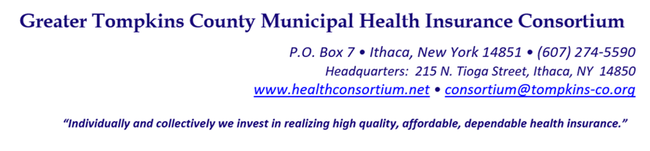
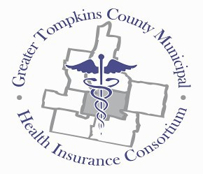

RESOLUTION NO. 037-2022 - AUTHORIZATION TO PURCHASE INSURANCE POLICIES:
ERRORS AND OMISSIONS, DIRECTORS AND OFFICERS LIABILITY, EMPLOYMENT PROTECTION COVERAGE, AND A FIDELITY BOND

MOVED by Mr. Salton, seconded by Mr. Snow. The resolution was unanimously adopted by voice vote of members present, visibly seen members via remote Satellite locations, and locations due to extraordinary circumstances to approve the following resolution.

WHEREAS, it is the desire of the Board of Directors to ensure liability coverage for the Consortium, the Board of Directors personally and professionally, and the participating municipalities, now therefore be it

RESOLVED, on recommendation of the Audit and Finance Committee, That the Consortium shall purchase coverage for these policies from the following for the period January 1, 2023 thru December 31, 2023:

- Errors and Omissions Insurance at $1,000,000 limit with $25,000 retention (placed by insurance agent Haylor, Freyer and Coon);
- Directors and Officers Liability Insurance at $1,000,000 limit with $25,000 retention and Employment Protection Liability at $1,000,000 limit (placed by insurance agent Haylor, Freyer and Coon); and
- A Fidelity Bond

RESOLVED, further, That the Executive Director is authorized to execute the renewal documents for the policies listed above.

* * * * * * * * *

STATE OF NEW YORK )
GTCMHIC ) ss:
COUNTY OF TOMPKINS )

I hereby certify that the foregoing is a true and correct transcript of a resolution adopted by the Greater Tompkins County Municipal Health Insurance Consortium Executive Committee on behalf of the Board of Directors on December 7, 2022.
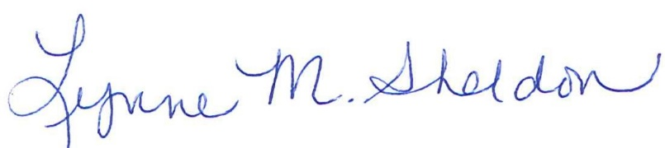

______________________________________
Lynne Sheldon, Clerk of the GTCMHIC Board

