RESOLUTION NO. 036-2022– EXTENSION OF CONTRACT FOR INVESTMENT MANAGEMENT SERVICES – WILMINGTON TRUST ADVISORS, INC.

MOVED by Mr. Mutchler, seconded by Ms. DeVoe. The resolution was unanimously adopted by voice vote of members present, visibly seen members via remote Satellite locations, and locations due to extraordinary circumstances.

WHEREAS, the Consortium secures services from Wilmington Trust Advisors, Inc. for investment management services as it pertains to our Investment Management Policy pursuant to Resolution No. 16 of 2020 and wishes to extend its contractual relationship into 2023, and

WHEREAS, the Consortium directed the Finance Manager to commence an Investment Management Request for Proposal (RFP) in 2023 to determine options available to assist in managing our reserves and unencumbered fund balance, and

WHEREAS, the Board of Directors approved a new Investment Policy Statement (Resolution No. 017-2022) in September 2022 and postponed the RFP until 2023 to allow Wilmington Trust to garner any new investment options available under the policy, therefore now be it

RESOLVED, on recommendation of the Audit and Finance Committee, That the Executive Committee, on behalf of the Board of Directors, authorizes the Consortium to extend its contract with Wilmington Trust Advisors, Inc. (WTIA) for investment management services beginning January 1, 2023 through the conclusion of the RFP process and/or selection of a new Investment Manager.

***********

GTCMHIC ) ss:
COUNTY OF TOMPKINS )
STATE OF NEW YORK )

I hereby certify that the foregoing is a true and correct transcript of a resolution adopted by the Greater Tompkins County Municipal Health Insurance Consortium Executive Committee on behalf of the Board of Directors on December 7, 2022.
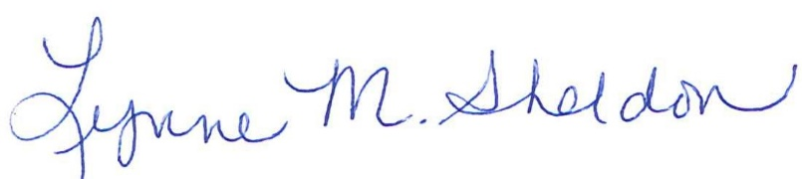

______________________________________
Lynne Sheldon, Clerk of the GTCMHIC Board

