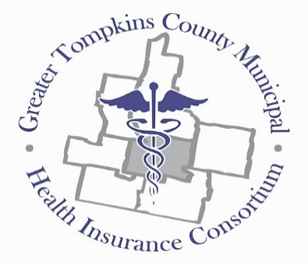
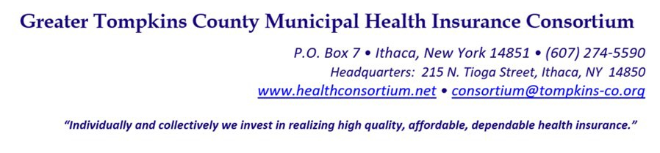

RESOLUTION NO. 033–2022 – DIRECTIVE TO PRESCRIPTION BENEFIT MANAGER- MEDICARE SUPPLEMENT IMMUNIZATION AND INSULIN PRODUCTS BENEFIT

MOVED by Ms. Holmes, seconded by Mr. Mutchler. The resolution was unanimously adopted by voice vote of members present, visibly seen members via remote Satellite locations, and locations due to extraordinary circumstances.

WHEREAS, on August 16, 2022, the 117th United States Congress passed the Inflation Reduction Act, in which set clear federal guidelines for Medicare Part D plans to follow, and

WHEREAS, the prescription drug coverage for the Greater Tompkins County Municipal Health Insurance Consortium (GTCMHIC) to maintain a level of creditable coverage for Medicare-age retirees must follow all Part D plan federal mandates, and

WHEREAS, the Inflation Reduction Act, mandated the elimination of any cost-share for Advisory Committee on Immunization Practices (ACIP)- recommended immunizations covered under Medicare Part D plans. According to the Department of Health and Human Services, Medicare Part D plans cover all vaccines that are, commercially available, reasonable, and necessary to prevent illness and not covered by Medicare Part B, and

WHEREAS, the Inflation Reduction Act further mandated a maximum $35 copay for a 30-day supply per prescription for any insulin product, now therefore be it

RESOLVED, on recommendation of the Joint Committee on Plan Structure and Design, that the Executive Committee hereby directs Proact to provide full coverage for standard Part D covered immunization for all the Consortium Medicare Supplement plans,

RESOLVED, further, That all insulin products maintain a $35 copay or less, for a 30-day supply per prescription for all the Consortium Medicare Supplement plans,

RESOLVED, further, That this directive shall be effective January 1, 2023.
***********

STATE OF NEW YORK )
GTCMHIC ) ss:
COUNTY OF TOMPKINS )

I hereby certify that the foregoing is a true and correct transcript of a resolution adopted by the Greater Tompkins County Municipal Health Insurance Consortium Executive Committee on behalf of the Board of Directors on December 7, 2022.
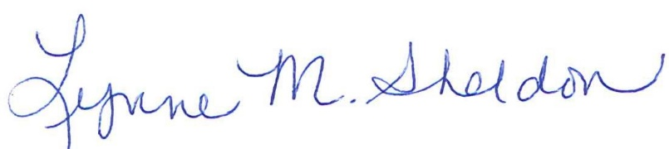

______________________________________
Lynne Sheldon, Clerk of the GTCMHIC Board

